# Target Metrics

Overall - Accuracy: 0.7500, Precision: 0.7507, Recall: 0.7500, F1: 0.7449

Class-specific metrics:

Carbon neutral(ity) - Precision: 0.7222, Recall: 0.5200, F1: 0.6047

Emissions reduction target - Precision: 0.6552, Recall: 0.7600, F1: 0.7037

Net zero - Precision: 0.7407, Recall: 0.8000, F1: 0.7692

No target - Precision: 0.8846, Recall: 0.9200, F1: 0.9020

# Year Metrics

Overall - Accuracy: 0.8000, Precision: 0.8077, Recall: 0.8000, F1: 0.7996

Class-specific metrics:

2020 - Precision: 0.0000, Recall: 0.0000, F1: 0.0000

2022 - Precision: 0.0000, Recall: 0.0000, F1: 0.0000

2025 - Precision: 0.6000, Recall: 0.6000, F1: 0.6000

2030 - Precision: 0.7333, Recall: 0.8800, F1: 0.8000

2031-32 - Precision: 0.0000, Recall: 0.0000, F1: 0.0000

2031.3 - Precision: 0.0000, Recall: 0.0000, F1: 0.0000

2032 - Precision: 0.0000, Recall: 0.0000, F1: 0.0000

2035 - Precision: 0.8000, Recall: 0.8000, F1: 0.8000

2039 - Precision: 0.0000, Recall: 0.0000, F1: 0.0000

2040 - Precision: 1.0000, Recall: 0.9000, F1: 0.9474

2050 - Precision: 0.8636, Recall: 0.7037, F1: 0.7755

No target - Precision: 0.8846, Recall: 0.9200, F1: 0.9020

# Other Metrics

Quote Accuracy: 0.6600

Overall Accuracy: 0.6900

Valid XML Percentage: 1.0000

# Confusion Matrices

Target Confusion Matrix:

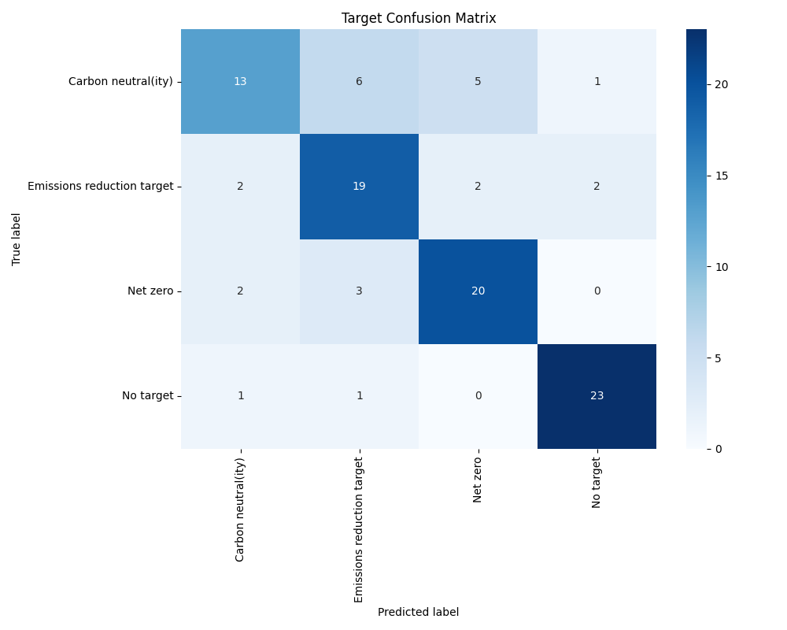

Year Confusion Matrix:

